

RESOURCES – WORKBOOK
COMPUTER NETWORK
student nAME: Joseph Janone Tiwouw
inSTRuctor: Jimmy MoedjaHEDY
Universitas Klabat
airmadidi-minahasa utara
Version 1.5

RESOURCES – WORKBOOK
COMPUTER NETWORK

wINDOWS SERVER 2012

goal
- DNS SERVER SETTING ON WINDOWS SERVER 2008

LIST OF ACTIVITIES
 | Activities
 | Install web server apache (Done in module B)
 | Config DNS server and screen shot config process
 | Parent domain: namaanda.org
4. | Create Host A
5. | Make sure the DNS server configuration running well by trying to access your file through DNS, for example namaanda.org instead of localhost or 192.168.1.1
6. | Capture your browser while accessing your DNS/domain
7. | Add sub domain: unklab.naamanda.org, access your web and capture

- Access Server Manager
- Add roles and features
- Click the check box for DNS Server and click Next.
- Take a few moments to review the information about DNS Server, Click Next.
- Install your DNS

DNS Zones
DNS name resolution is enabled through the use of tables of information that link computer names and IP addresses. The tables are associated with partitions in a DNS server that are called zones and that contain resource records. Each zone houses tables, called the zone file or zone database, of different types of resource records, such as records that link a computer name to an IP address.
The zone that links computer names to IP addresses is called the forward lookup zone, which holds host name records called address records. Each IP-based server and client should have a host record so that it can be found through DNS. For example, if the DNS server name is Accounting, with the IP address 129.70.10.1, then the forward lookup zone maps Accounting to 129.70.10.1. In IP version 4, a host record is called a host address (A) resource record. IP version 6 (IPv6), the newer version of IP that is used primarily on educational and experimental networks, consists of a 128-bit address (instead of the 32-bit address used with IPv4). An IPv6 record is called an IPv6 host address (AAAA) resource record. Microsoft, along with other major network software and hardware vendors, has made a commitment to implement IPv6. When you install DNS on a domain controller (DC) in a domain, a forward lookup zone is automatically created for the domain with the DNS server’s address record already entered. You must enter the records of other hosts or configure Dynamic Host Configuration Protocol (DHCP) to automatically update the DNS forward lookup zone each time it leases an IP address.

Depending on the domain structure and Internet connectivity, a DNS server can have several forward lookup zones, but there should be at least one for the parent domain, such as jpcomp.com. Another zone, called the reverse lookup zone, holds the pointer (PTR) resource record, which contains the IP address-to-host name. The reverse lookup zone is not used as commonly as the forward lookup zone, but can be important to create for those instances when a network communication requires associating an IP address to a computer name, such as for monitoring a network using IP address information. Because it is less commonly used, the reverse lookup zone is not automatically configured when DNS is installed. If you anticipate that there will be users who access your network off-site, such as over the Internet, however, plan to implement information in a reverse lookup zone. Table below summarizes the commonly used resource records in DNS.
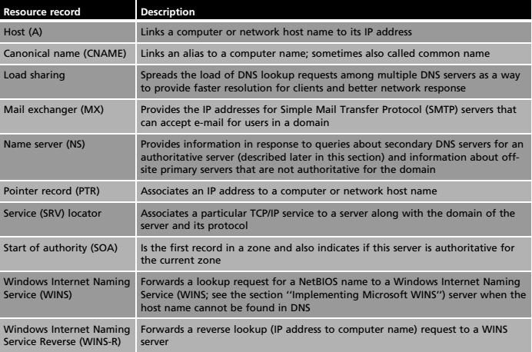

When configuring your DNS server, you must be familiar with the following concepts:
- Forward lookup zone
- Reverse lookup zone
- Zone types
A forward lookup zone is simply a way to resolve host names to IP addresses. A reverse lookup zone allows a DNS server to discover the DNS name of the host. Basically, it is the exact opposite of a forward lookup zone. A reverse lookup zone is not required, but it is easy to configure and will allow for your Windows Server 2008 Server to have full DNS functionality.
When selecting a DNS zone type, you have the following options: Active Directory (AD) Integrated, Standard Primary, and Standard Secondary. AD Integrated stores the database information in AD and allows for secure updates to the database file. This option will appear only if AD is configured. If it is configured and you select this option, AD will store and replicate your zone files.
A Standard Primary zone stores the database in a text file. This text file can be shared with other DNS servers that store their information in a text file. Finally, a Standard Secondary zone simply creates a copy of the existing database from another DNS server. This is primarily used for load balancing.

Host (A) records
A Host (A) record maps a host name to an IP address. These records help you easily identify another server in a forward lookup zone. Host records improve query performance in multiple-zone environments, and you can also create a Pointer (PTR) record at the same time. A PTR record resolves an IP address to a host name.

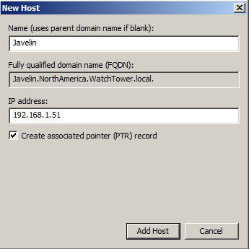

A Host (A) record

Answer sheet for a. Config dns server
2.
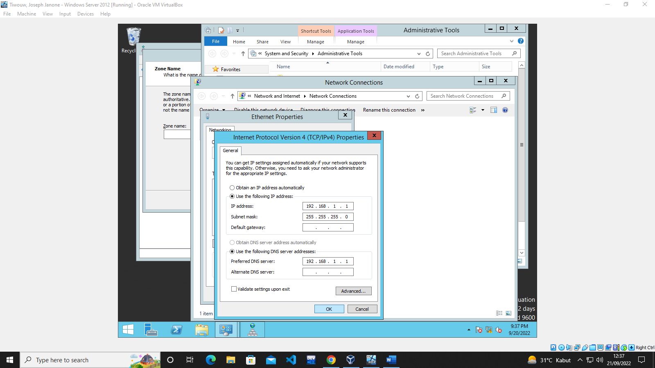

3.
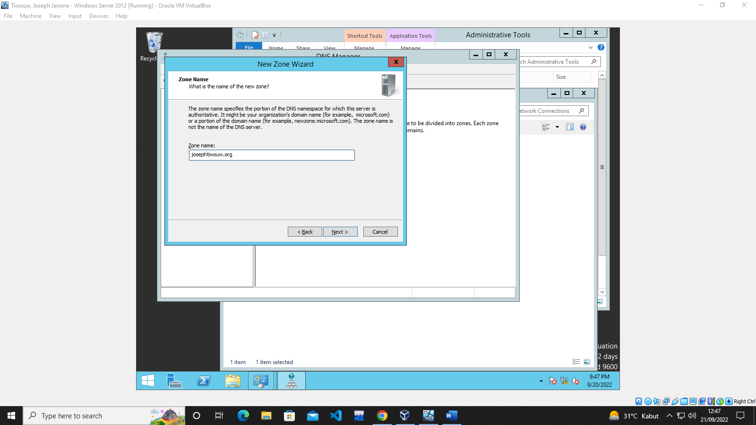

4/6.
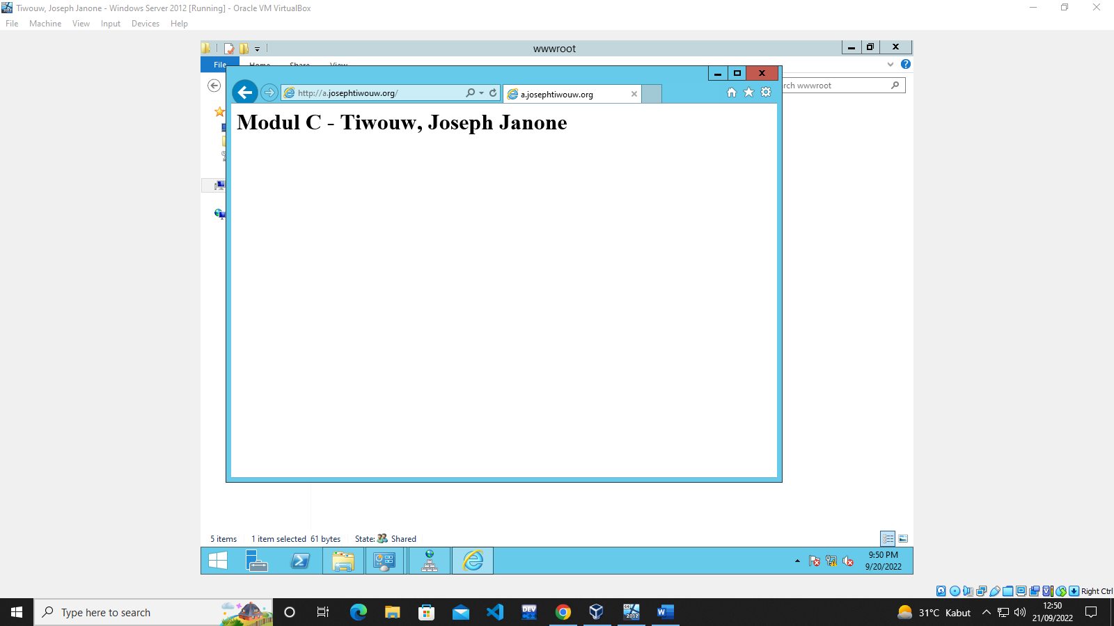

7.
